**Demand Forecasting and Waste Optimization Strategies for Doon**

**Bites Restaurant**

**Mid Term report for the BDM Capstone Project**

Submitted by

**Name**: Rushil Gupta

**Roll number**: 21f1006728

**Email ID**: 21f1006728@ds.study.iitm.ac.in



IITM Online BS Degree Program,

Indian Institute of Technology, Madras, Chennai

Tamil Nadu, India, 600036

**Contents**

1. Executive Summary and Title 3

2. Proof of Originality 3

3. Metadata 5

4. Descriptive Statistics 7

5. Detailed Explanation of Analysis Process/Method 8

6. Results and Findings 9

7. Conclusion 11

**Executive Summary and Title**

Doon Bites is a small and relatively new food outlet in Krishna Nagar, Lucknow, Uttar Pradesh, India. It was established in January 2021 and is a B2C business model which serves vegetarian fast-food dishes. It particularly specializes in Chinese dishes, and operates on all days of the week, from 5PM to 10PM.

It also has its presence on various food order and delivery platforms such as Swiggy and Zomato, focusing on reaching as many customers as possible.

Despite Lucknow being famous for its food (especially street food) which typically attracts a lot of customers in this line of business, Doon Bites is not faring as well as it should have been. Besides facing the perennial challenges of heavy competition, it also deals with the issue of significant waste being generated and the inability to handle orders at times, leading to lesser profits than ideal. The fact that this business is not located in a busy, commercial part of the city also adds up to the lack of sufficient customers.

This midterm report provides a detailed overview of the measures Doon Bites can take to address its challenges with the help of data analysis using Excel, which would lead to informed decision making.

**Proof Of Originality**

**Owner:** Mukul Rautela

**Address**: 01, Vinay Nagar, Krishna Nagar, Chowk, Lucknow, Uttar Pradesh. 226023

I reached out to this business through a mutual friend of mine who happened to know the owner. I expressed my interest in collaborating on a project to enhance Doon Bites’ operational efficiency and growth. The owner Mr. Mukul was very cooperative and provided me with data, as well as his insights and challenges involving his business. This initial contact set the stage for a collaborative and mutually beneficial engagement focused on leveraging data-driven strategies for the food outlet’s success.

Following are the various proofs of originality taken as part of my data collection process –

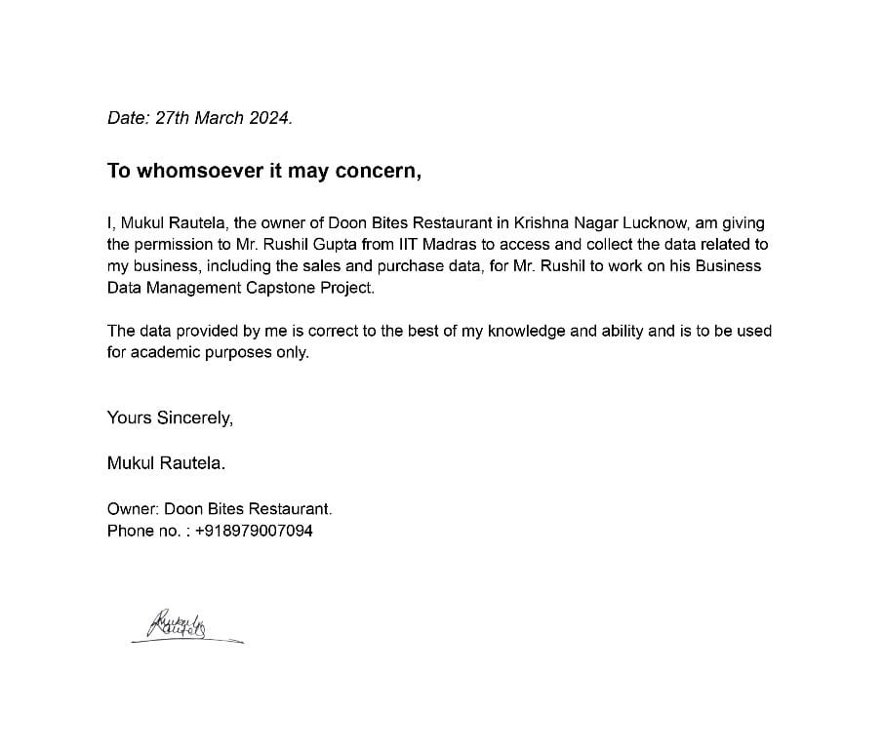

*Approval Letter from the Business Organization along with the signature of the owne****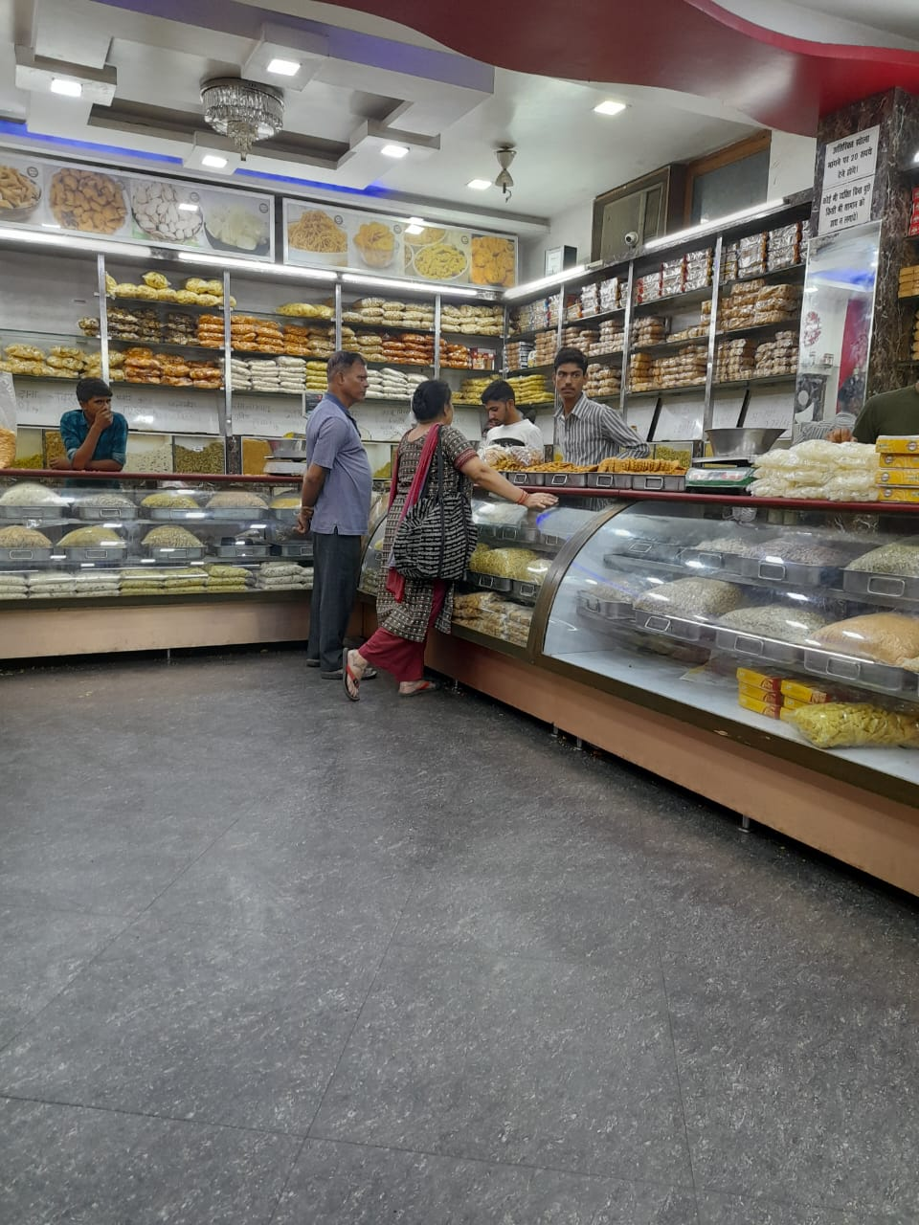****r.*



*Images of Doon Bites food outlet*



*Snippet of a zoom meet scheduled between me and Mr. Rautela*

**Metadata**

The data gathered from this small business for a time period of 45 days comprises of 4 different parts which cater to 4 different areas.

1. Menu (Dishes Data) – This data contains the list of all the dishes currently being served by Doon Bites, along with the approximate cost of making each dish.

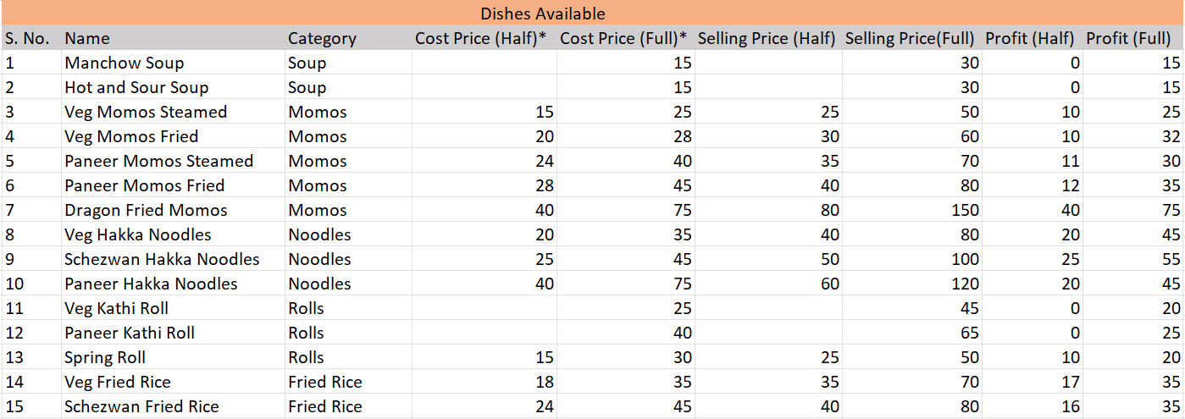

1. Raw Material Data – This data contains the raw materials consumed per day on average, in order to prepare these dishes.

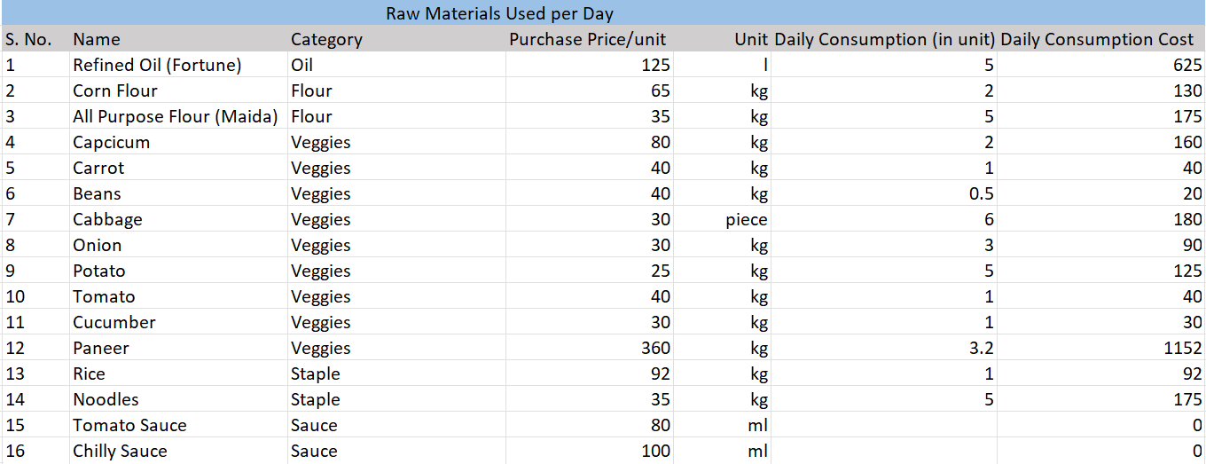

1. Sales Data – This data captures the sale of each dish on a daily basis. It also captures how an order was made i.e. In person, or through any delivery platform.

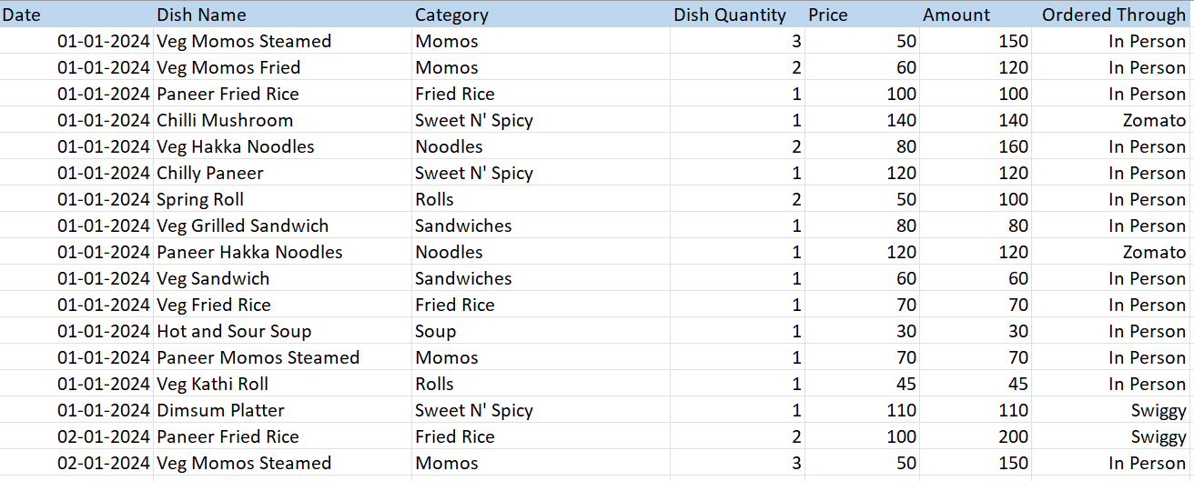

1. Purchase Data – This data captures the purchase of raw materials on a day to day basis.

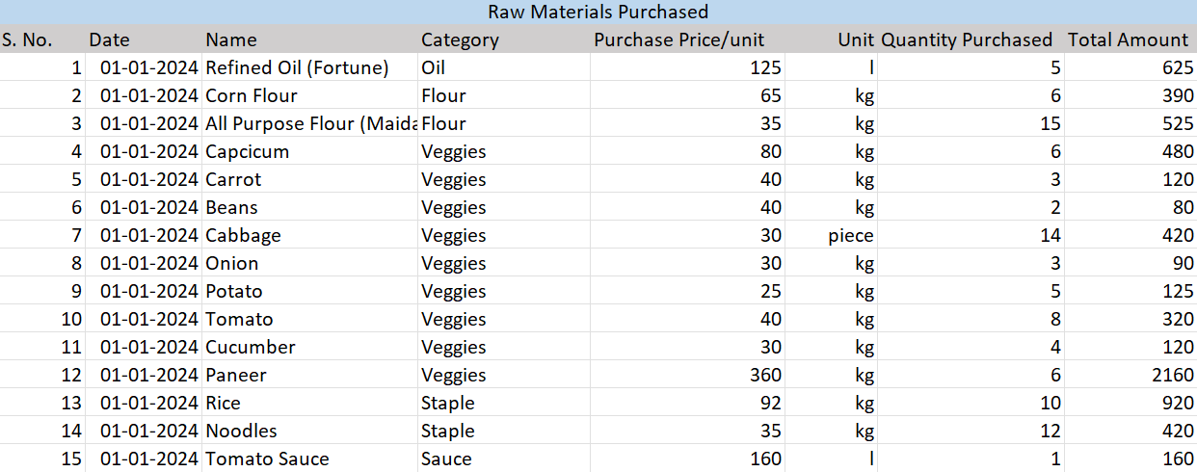

The primary challenge encountered while collecting all this data was in storing the data in Excel. Fortunately, there were manual records present, as well as orders history from platforms like Zomato and Swiggy, which made it easier to capture the unprocessed data from all these sources instead of entering them manually. After that, several preprocessing steps were needed to ensure the cohesiveness and the integrity of the data captured.

**Descriptive Statistics**

The following statistical insights provide a nuanced perspective, highlighting key areas for statistical analysis and strategic improvement within Doon Bites’ operational and sales dynamics.

**1. Total Orders:** In the time period of 45 days, spanning from 1st January 2024 to 15th February 2024, a total of **1373 orders** were made.

This makes it roughly **30 orders per day** on an averageor **6 orders per hour** (the business is only operational for 5 hours in the evening).

**2. Total Sales:** In this time span of 45 days, the business had total sales amounting to **78,860 INR.**

**3. Average Sales**: The average sale per day would be around **1752.44 INR**. This would roughly translate to **52,573 INR** of monthly sales on an average.

**4. Ordered Through:** Around **71%** of the orders were made in person by people who visited the outlet. Food ordering and delivery platforms only contributed to **27%** of their total orders.

**5. Average Order Amount:** An average order amounted to roughly **64 INR,** indicating that people usually made light orders.

**6. Average Raw Materials Used:** The business used raw materials worth **526 INR** on an average per day. This would sum up to **15780 INR** per month on average.

**7. Average Raw Materials Wasted:** Raw materials worth approx. **INR 343** went wasted per day on an average. The average monthly waste generated in INR would be **10290**.

**8. Average Profit Earned:** Average Sales per day – Average Raw Material Cost Used per day – Average Raw Material Cost Wasted per day = 1752.44 – 526 – 343 = **883 INR** per day**.** This would make the average monthly Profit as approx**. 26500 INR.**

**Detailed Explanation of The Analysis Process/ Methods:**

1. **Data Collection and Preprocessing**

The data collection process spanned 45 days, from January 1, 2024, to February 15, 2024, this included both purchase and sales data, as well as collecting data about the cost price and selling price of each dish in the menu and data pertaining to the consumption of raw material. Due to seasonal inconsistencies in the prices of raw materials, and some hidden costs involving food packaging and preparation methods, the cost price of preparing each dish has been taken as an average of all the known factors involved, in consultation with the business owner. Same goes for the cost of raw materials purchased.

Furthermore, steps have been taken to ensure that all the data is stored in a proper structured format and there are no missing values or data capturing errors or inconsistencies.

1. **Descriptive Statistical Techniques**

Once the data was correctly stored in the excel sheet, the categorization of dishes and raw materials was done. Then measures like sum, average, total count, profit, and inventory stocks were applied to get a statistical idea of the business’ sales and purchase. A pivot table was created to better understand the key figures of each category/item.

1. **Graphing of Data**

Various chart types, including column, bar, line, and pie charts, were employed to visually represent number of orders, dish profits, selling prices, categories and their respective proportions, offering a clear and concise understanding of business metrics. These visualizations helped in identifying trends, patterns, and areas requiring attention for strategic decision-making.

A pie chart was used to understand the proportion of orders, a line chart was used to identify the trend in sales, bar charts were used to compare the performance of different categories and so on.

1. **Understanding Trends and Deriving Conclusions**

Once the charts and graphs are drawn, the patterns emerged were observed and noted, and explanations for the same were sought from the data given. Areas to be worked upon were discovered and potential solutions for the same were considered with the backing of data.

**Results And Findings**

**1. Top Selling Categories**

The food outlet served 30 different types of foods which were categorized into 8 categories. On visualizing these categories based on the number of orders they were a part of, we notice that the category **Sweet N’ Spicy** had the maximum number of orders, approximately 24% of the total orders. This was followed by **Momos** category which received around 20% of the total orders in this time period. This suggests that the business is renowned for certain dishes whose demand is much more than that of others such as **Sandwiches** or **Soup**.

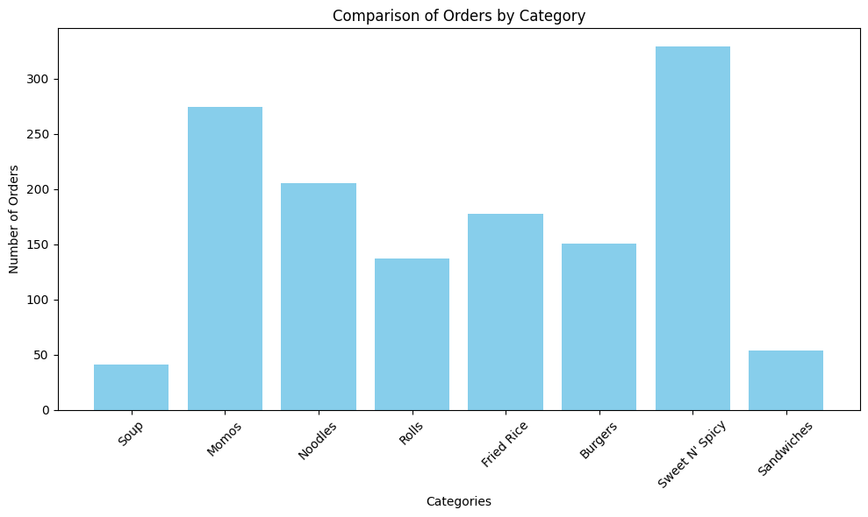

*Bar Chart comparing the categories of food items based on no. of orders*

**2. Weekly Sales Analysis:**

The graph depicts a rather consistent weekly sales range, lying between 1300 INR and 2000 INR. Occasional fluctuations are observed, likely influenced by various factors, including public holidays or weekends. Further analysis needs to be done to understand certain rise and drop patterns in this graph.

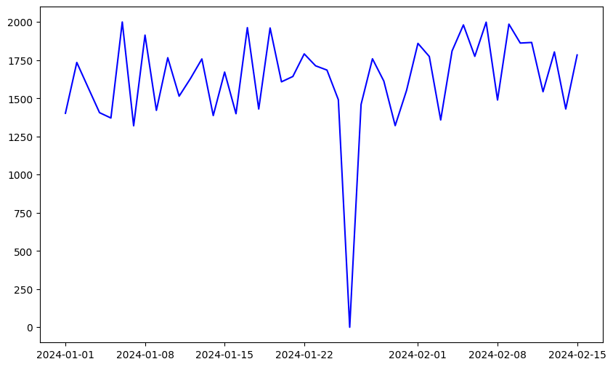

**3. Nature of Orders Analysis:**

This Pie chart indicates that the bulk of the orders received by the business come from the people who actually visit the outlet in person, and online platforms contribute little to the number of orders and subsequently the sales of this business. This perhaps indicates that this outlet is more suited for having quick bites on the go as compared to ordering food online, suggesting better alternatives are available in the online market. This topic needs to be studied in depth as well.

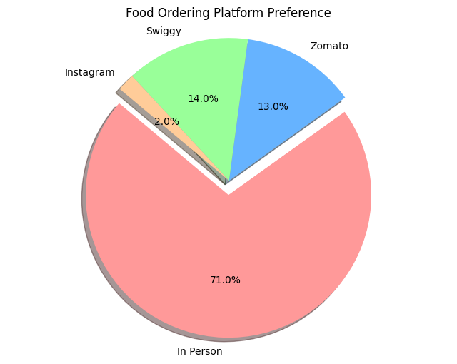

**4. Waste Analysis:**

To find out which category was generating the most waste, a pie chart was created to compare the raw material categories by the proportion of waste they generate. Obviously, the veggies category contributed to a maximum amount of waste, at 2/3 of the total. This is most likely due to the fact that vegetables get rotten and unfit of consumption after a couple of days. Further analysis needs to be done to understand which veggies are contributing the most to waste generation and how they can be optimized to reduce waste.

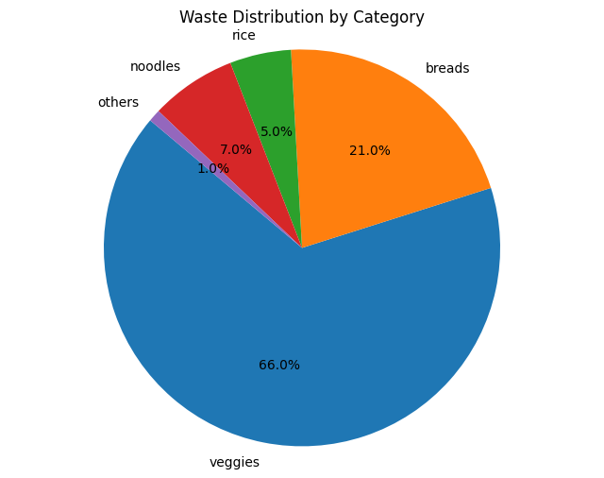

**Conclusion**

Meticulous collection, cleaning and processing of data, along with some statistical insights applied; gave an insight into Doon Bites’ business operations, while the graphs and charts highlighted some key areas to be noticed and inspected further. This has paved the way to find real world strategies to optimize waste and leverage the data backed prediction of sales in order to maximize profit and increase efficiency.